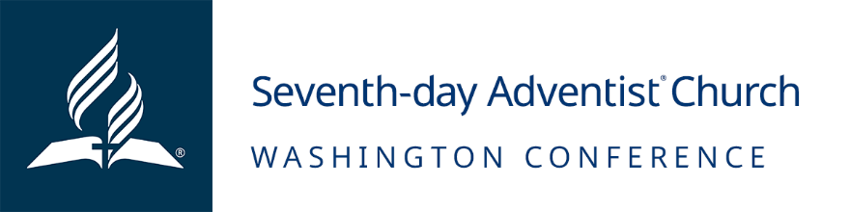

Job Opening: Auburn Adventist Academy Janitor
April 18, 2024

MISSION:
To reach western Washington with the distinctive, Christ-centered Seventh-day Adventist message of hope and wholeness, encouraging all to become fully devoted disciples of Jesus.
POSITION SUMMARY
The Auburn Adventist Academy Janitor is responsible for maintaining all bathrooms, classrooms and meeting spaces in clean condition, representative of the important Kingdom work that is done at the school. It is our goal that nothing stands between our students and faculty and the cross. The cleanliness of our facility is central to that goal. The janitor works under the direction of the Vice Principal to ensure that the school is cleaned and that all facilities are deep cleaned on a routine schedule.
ESSENTIAL FUNCTIONS
- Maintains all classrooms, restrooms, meeting rooms and dining hall in clean condition
- Deep cleans the facility on a set schedule to ensure the highest quality educational experience
- Refills paper towel dispensers, toilet paper dispensers, and soap dispensers
- Empty trash, cleans sinks and toilets, mirror, and window, mop and restock with supplies
- Vacuum common areas and administration offices, trash, dust, and clean window
- May also supervise student workers to assist with the cleaning
- Alerts Vice Principal when cleaning supplies and paper products are needed
- Other duties as requested by the Vice Principal
KNOWLEDGE AND SKILL
Must have a heart for service and an attention to detail. Must be organized and able to maintain living and working spaces in neat and orderly condition. Must get along well with people and be willing to take direction. Must excel at people skills and able to make all who come on school campus feel like a part of the family. Well-developed knowledge of principles, policies and beliefs of the Seventh-day Adventist Church and the Washington Conference. Must exhibit initiative; often working with minimal supervision. Adaptable and able to evaluate priorities. Ability to perform duties with speed and accuracy without constant supervision. Must be able to facilitate good communication.
EDUCATION/EXPERIENCE/CREDENTIALS
At least a high school diploma. Prior janitorial work preferred, but not required.

HOURLY RATE:
$16.28 - $21
Wage Details
Pay is based on Community Wage Scale. Pay will also be based on multiple factors, including, and not limited to relevant experience/level and skillset.
BENEFITS:
Washington Conference pay and benefits can vary by number of regularly scheduled hours worked, length of employment, and employment status.
- Employer retirement and matching contributions
- Holiday and paid time off
ADDITIONAL INFORMATION:
- Apply by 7:00 PM Pacific Time on 5/31/2024
- Employment Type: Part-Time (20 hours)
- FLSA Status: Hourly Non-Exempt
- Regular/Temporary: Regular
- Work Location: Auburn Adventist Academy
EQUAL EMPLOYMENT OPPORTUNITY
The Washington Conference of Seventh-day Adventists is an equal opportunity employer and does not discriminate against qualified applicants or employees on account of race, color, sex, age, national origin, marital status, physical or mental disability, or other protected categories under Washington laws, regulations or local ordinances. The Washington Conference prohibits any form of workplace harassment, misconduct or abuse. The Washington Conference hires Seventh-day Adventist Church members in good standing based on religious preferences permitted by the United States Constitution and controlling law.

