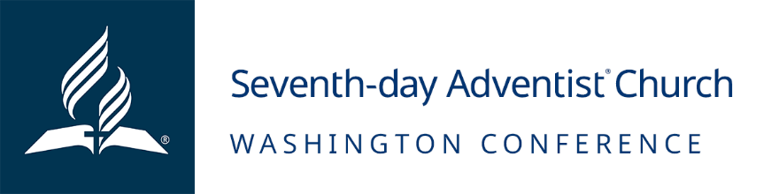

Job Opening: Planned Giving & Trust Services
October 1, 2023
MISSION:
To reach western Washington with the distinctive, Christ-centered Seventh-day Adventist message of hope and wholeness, encouraging all to become fully devoted disciples of Jesus.

POSITION SUMMARY:
Performs diverse office and/or secretarial duties for the Planned Giving & Trust Services Department of the Washington Conference. Assist in designated administrative duties using initiative and sound judgment. Requires high level of technical (well-developed keyboard/computer, etc.) skills, confidentiality, high levels of tact, friendliness, customer service and other aspects of strongly developed interpersonal skills plus proven organizational skills.
ESSENTIAL FUNCTIONS:
- Maintain a well-organized office, often in the absence of supervisor, with efficient filing system.
- Produce, mail, file, and scan important correspondence as needed.
- Schedule and maintain department calendar of events.
- Screen telephone calls - responds to routine/non-routine inquiries and refers complex or unusual inquiries to supervisor or to appropriate offices.
- Process incoming mail-opening, dating, sorting.
- Produce professional correspondence or other written material.
- Process all routine purchase orders as needed by department.
- Assist supervisor in preparation of various committee agendas, performs recording secretary functions for committees. Includes taking and producing minutes for supervisor review, following the standardized notification process of committee actions.
- Serve as custodian of minutes, documents and records of the administration office and can retrieve the same as needed.
- Assist supervisor in preparing reports, special projects, etc. as needed.
- Maintain client’s database and mail birthday cards to all in advance.
- Plan and organize social activities for the department when desired and approved.
- Carry much of the office responsibilities when the supervisors are gone or in meetings.
- Cover receptionist/front desk on a weekly basis
- Assist and support with SAGE ministries
- Other duties as assigned by supervisor and Human Resource department.

Qualifications/Requirements
- Education:
- Administrative assistant related degree/certification or equivalent experience recommended.
- Membership in a local, Washington Conference church
- A Seventh-day Adventist member in good standing who has extensive knowledge of the practices and beliefs of the Seventh-day Adventist church
- Must be willing to contribute tithes and offerings to the local church
- Competencies (skills and personal characteristics that an individual should possess to be successful in this position)
- Ability to carry out duties and meet deadlines independently.
- Requires high level of technical (well-developed keyboard/computer, Microsoft office, Google docs, etc.) skills, confidentiality, high levels of tact, friendliness, customer service and other aspects of strongly developed interpersonal skills plus proven organization skills.
- Effectively communicate with written, visual and verbal skills
- Establish and maintain cooperative and effective working relationships with others
- Solve problems proactively
- Maintain confidential information appropriately and exercise good judgment when communicating to the public
- Work independently with little direction
- Adaptable and able to evaluate priorities.
- Ability to perform secretarial and support duties with speed and accuracy without constant supervision.
- Must be creative in writing letters and in the handling of office affairs, both regular and special.
- Knowledge of up-to-date office procedures such as office equipment, telephone techniques and filing and the English language.
- Must be able to facilitate good communication with all who are in contact with the office.
- Ability to work on deadlines both independently and as part of a team

HOURLY RATE:
$18 - $24
Wage Details
Pay is based on Community Wage Scale. Pay will also be based on multiple factors, including, and not limited to relevant experience/level and skillset.
BENEFITS:
Washington Conference pay and benefits can vary by number of regularly scheduled hours worked, length of employment, and employment status.
- Employer retirement and matching contributions
- Annual bonus
- Holiday and paid time off
ADDITIONAL INFORMATION:
- Apply by 7:00 PM Pacific Time on 11/30/2023
- Employment Type: Part-Time (20+ hours)
- FLSA Status: Hourly Non-Exempt
- Work Location: WA Conference Office in Federal Way
EQUAL EMPLOYMENT OPPORTUNITY
The Washington Conference of Seventh-day Adventists is an equal opportunity employer and does not discriminate against qualified applicants or employees on account of race, color, sex, age, national origin, marital status, physical or mental disability, or other protected categories under Washington laws, regulations or local ordinances. The Washington Conference prohibits any form of workplace harassment, misconduct or abuse. The Washington Conference hires Seventh-day Adventist Church members in good standing based on religious preferences permitted by the United States Constitution and controlling law.

